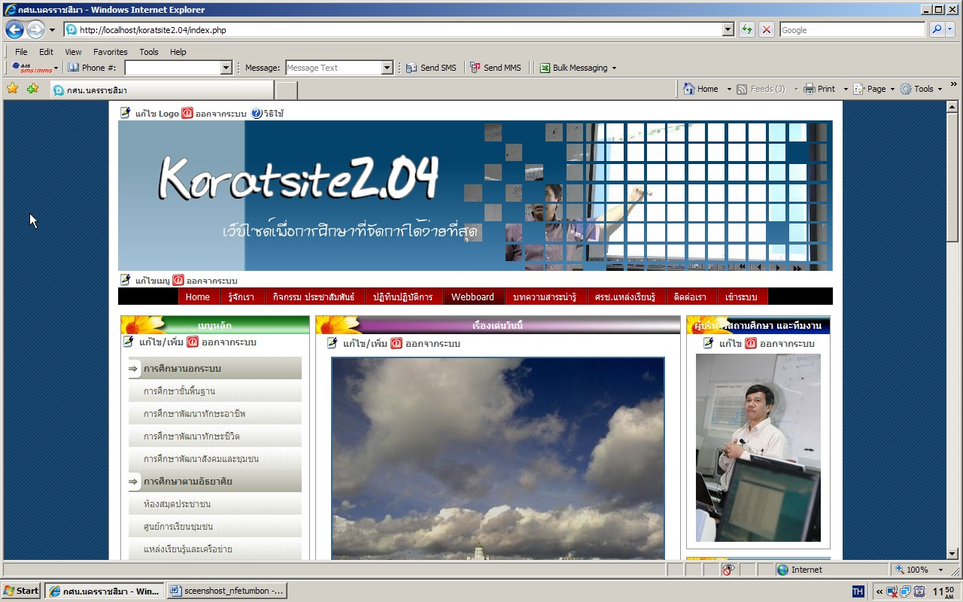
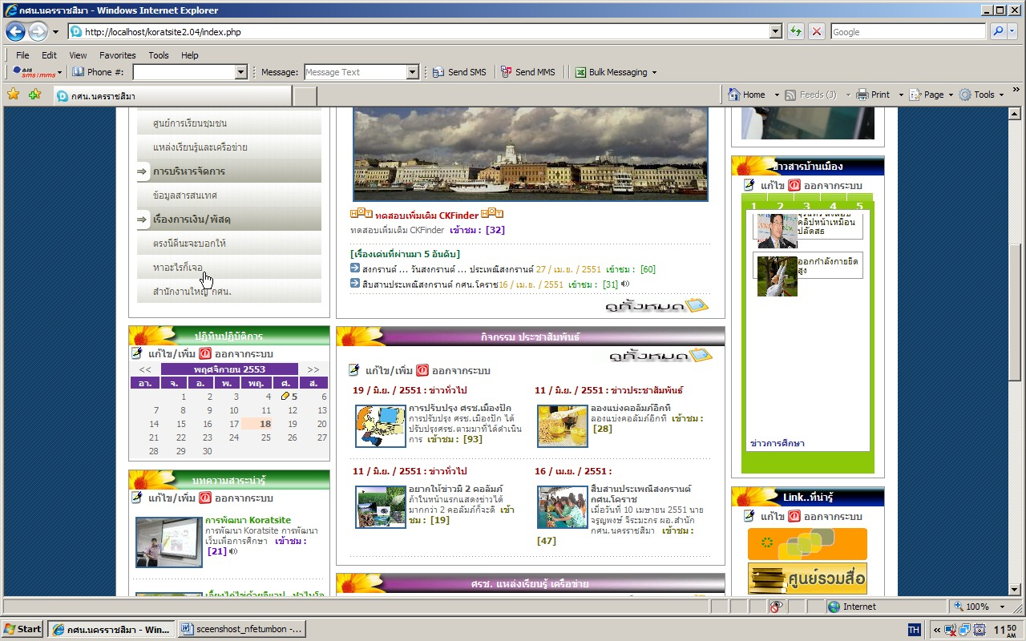
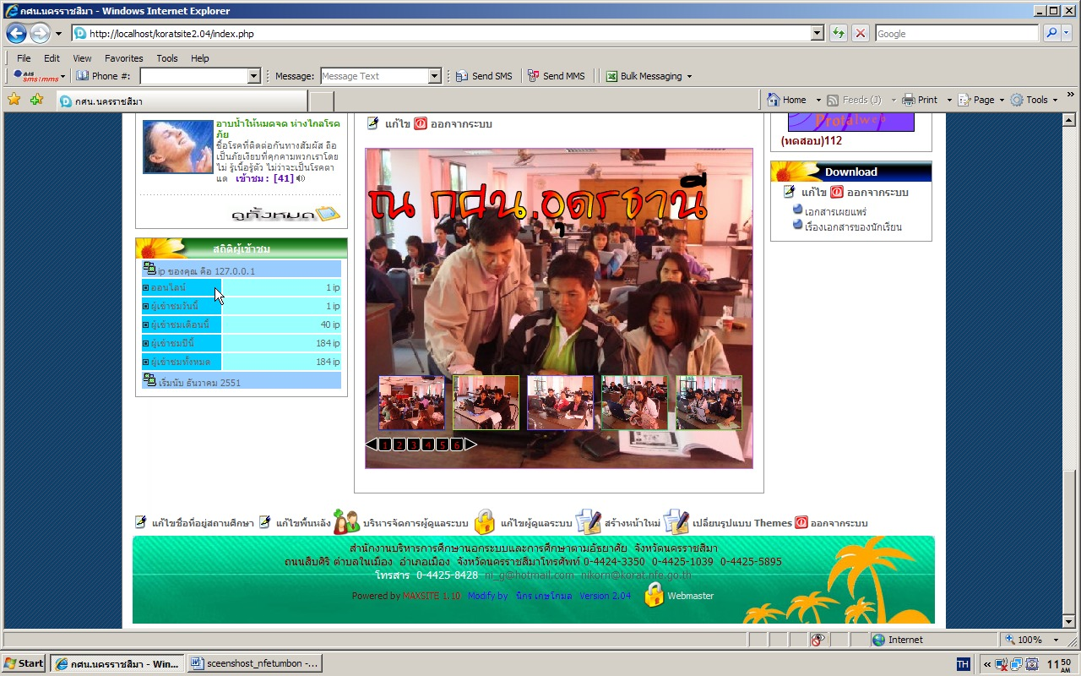
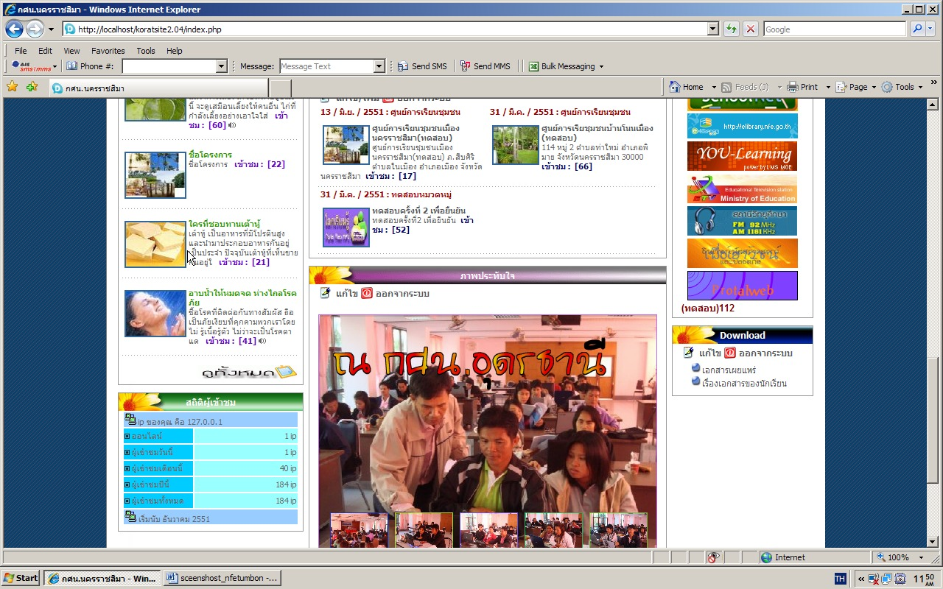
New2
nfe11

nfe10
editortalk5
editortalk3:ชื่อที่อยู่
editortalk2
knowledge
news1
news
knowledge1
editortalk
editortalk4
editortalk1
editortalk6
nfe9

